PRACTICAL-9 (2520090097)
give code for this question 1. Implement a file copy utility using low-level Linux file I/O system calls (open, read, write, lseek, close). Compare its performance with standard library functions (fopen, fread, fwrite).
Develop a program that redirects standard input and output using file descriptors and dup2(). Demonstrate how shells implement I/O redirection.
#include <stdio.h>
#include <stdlib.h>
#include <fcntl.h>
#include <unistd.h>
#include <sys/time.h>

#define BUFFER_SIZE 4096

double get_time() {
struct timeval tv;
gettimeofday(&tv, NULL);
return tv.tv_sec + tv.tv_usec / 1000000.0;
}

void low_level_copy(const char *source, const char *destination) {
int src = open(source, O_RDONLY);
int dest = open(destination, O_WRONLY | O_CREAT | O_TRUNC, 0644);

if (src < 0 || dest < 0) {
perror("open");
exit(1);
}

char buffer[BUFFER_SIZE];
ssize_t bytes;

while ((bytes = read(src, buffer, BUFFER_SIZE)) > 0) {
write(dest, buffer, bytes);
}

lseek(src, 0, SEEK_SET);

close(src);
close(dest);
}

void standard_copy(const char *source, const char *destination) {
FILE *src = fopen(source, "rb");
FILE *dest = fopen(destination, "wb");

if (src == NULL || dest == NULL) {
perror("fopen");
exit(1);
}

char buffer[BUFFER_SIZE];
size_t bytes;

while ((bytes = fread(buffer, 1, BUFFER_SIZE, src)) > 0) {
fwrite(buffer, 1, bytes, dest);
}

fclose(src);
fclose(dest);
}

int main() {
const char *source = "input.txt";

double start, end;

printf("=== File Copy Performance Comparison ===\n");

start = get_time();
low_level_copy(source, "lowlevel.txt");
end = get_time();

printf("\nLow-Level I/O:\n");
printf("File copied to lowlevel.txt\n");
printf("Time taken: %.6f seconds\n", end - start);

start = get_time();
standard_copy(source, "standard.txt");
end = get_time();

printf("\nStandard Library I/O:\n");
printf("File copied to standard.txt\n");
printf("Time taken: %.6f seconds\n", end - start);

printf("\nComparison completed.\n");

return 0;
}
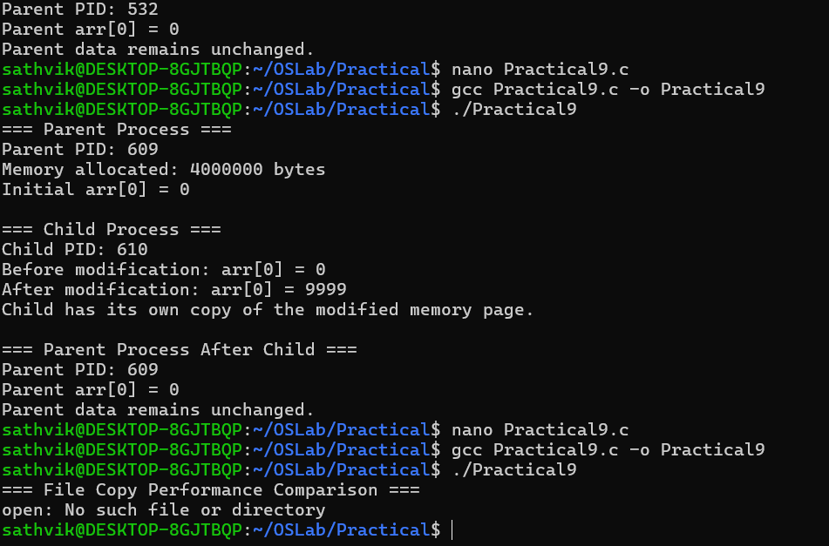

9B) #include <stdio.h>
#include <stdlib.h>
#include <fcntl.h>
#include <unistd.h>
#include <sys/time.h>

#define BUFFER_SIZE 4096

double get_time() {
struct timeval tv;
gettimeofday(&tv, NULL);
return tv.tv_sec + tv.tv_usec / 1000000.0;
}

void low_level_copy(const char *source, const char *destination) {
int src = open(source, O_RDONLY);
int dest = open(destination, O_WRONLY | O_CREAT | O_TRUNC, 0644);

if (src < 0 || dest < 0) {
perror("open");
exit(1);
}

char buffer[BUFFER_SIZE];
ssize_t bytes;

while ((bytes = read(src, buffer, BUFFER_SIZE)) > 0) {
write(dest, buffer, bytes);
}

lseek(src, 0, SEEK_SET);

close(src);
close(dest);
}

void standard_copy(const char *source, const char *destination) {
FILE *src = fopen(source, "rb");
FILE *dest = fopen(destination, "wb");

if (src == NULL || dest == NULL) {
perror("fopen");
exit(1);
}

char buffer[BUFFER_SIZE];
size_t bytes;

while ((bytes = fread(buffer, 1, BUFFER_SIZE, src)) > 0) {
fwrite(buffer, 1, bytes, dest);
}

fclose(src);
fclose(dest);
}

int main() {
const char *source = "input.txt";

double start, end;

printf("=== File Copy Performance Comparison ===\n");

start = get_time();
low_level_copy(source, "lowlevel.txt");
end = get_time();

printf("\nLow-Level I/O:\n");
printf("File copied to lowlevel.txt\n");
printf("Time taken: %.6f seconds\n", end - start);

start = get_time();
standard_copy(source, "standard.txt");
end = get_time();

printf("\nStandard Library I/O:\n");
printf("File copied to standard.txt\n");
printf("Time taken: %.6f seconds\n", end - start);

printf("\nComparison completed.\n");

return

